**FUNCTIONAL REQUIREMENTS OF ACADEMIC EDUTECH(CHATBOT)**

**1.Collage Enquiries**

A user who wishes to join a college will have a queries related to course to clarify which he will enter an collage website ,when the user enters the site the chatbot becomes active and responds to the queries of the user.Making the user experience effortless.

The user can enter any enquiries regarding the college ,that is admission enquiry ,fees structure, different courses offered to which the bot will reply with suitable answers.

**2.Collage Information**

Every student enters a collage website with a wide variety of queries like the location of the collage to details of the course provided by the collage. Information regarding the collage has to be provided by the bot,the chatbot is trained to do that.

**Functions provided by the chatbot are**

1.Collect User details

2.Chatbots answer questions and enquiries

3.Collect customer feedback

4.Course registration and enrollment queries

**______________________________________________________**

**CHATBOT - WORKFLOW**

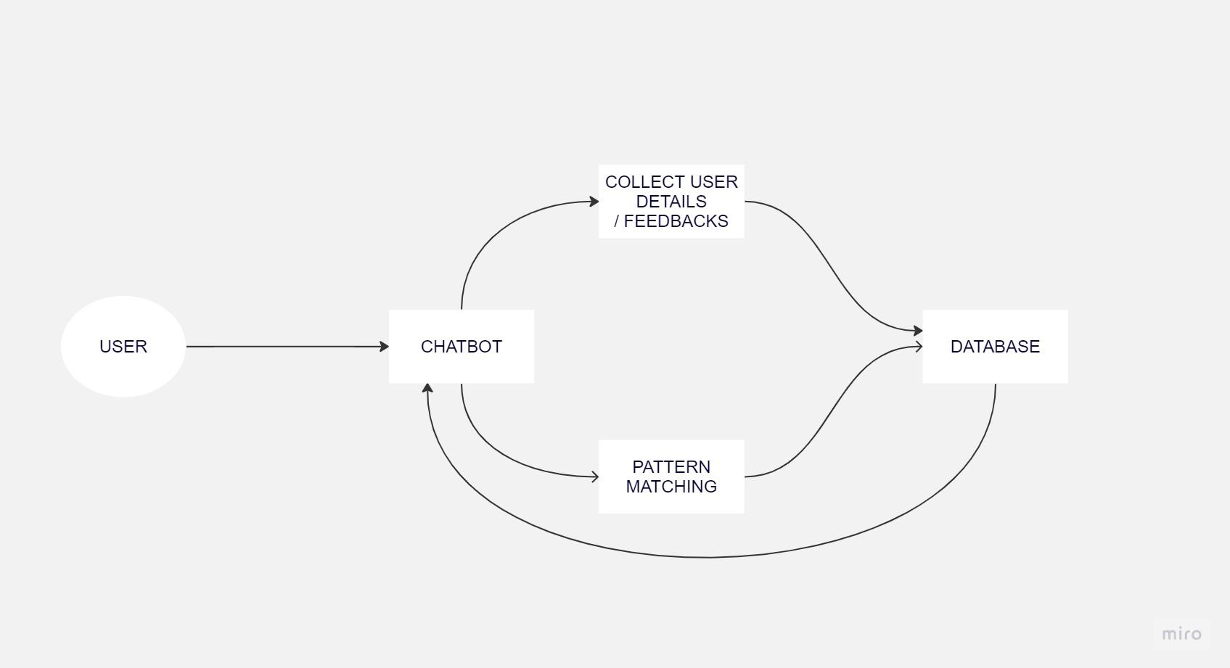

**Field name description:**

| Manage whom | Allows admin to select user or college |
| --- | --- |
| User list | Displays the list of users |

**Below fields appear if you click down against the college information:**

| Question | Questions the user can ask the chatbot |
| --- | --- |
| Answers | Answers for their respective questions |

**Below fields appear if you click down against the user information:**

| Student name | Name of the student to get admission |
| --- | --- |
| Email-id | Email id of the student |
| Date of admission | Date on which student is approaching college for admission |
| Branch | Branch preferred by student(Eg: CSE, ISE, AIML, etc) |
| Quota | Quota via which the student is getting admission (Eg: Management, KCET, etc) |

**______________________________________________________**

**To manage:**

**To manage college information:**

1. In the admin page the admin can **delete, add or update** the college information.
2. To achieve it the admin clicks on **update info** option to add any extra queries or update any changes regarding the college information.

* **To add the college information:** Clicking on the add option the admin can add details into the chatbot.
* **To edit the present information:** Admin can edit or change the information by clicking on edit option.
* **To delete the college details:** Clicking on the delete option the admin can delete details from the chatbot.

**To manage user information:**

1. Admin can view the user entered details regarding the **admission and feedback**.
2. To achieve it the admin clicks on **view user info** to view the admission details, user details and user feedback.

**______________________________________________________**